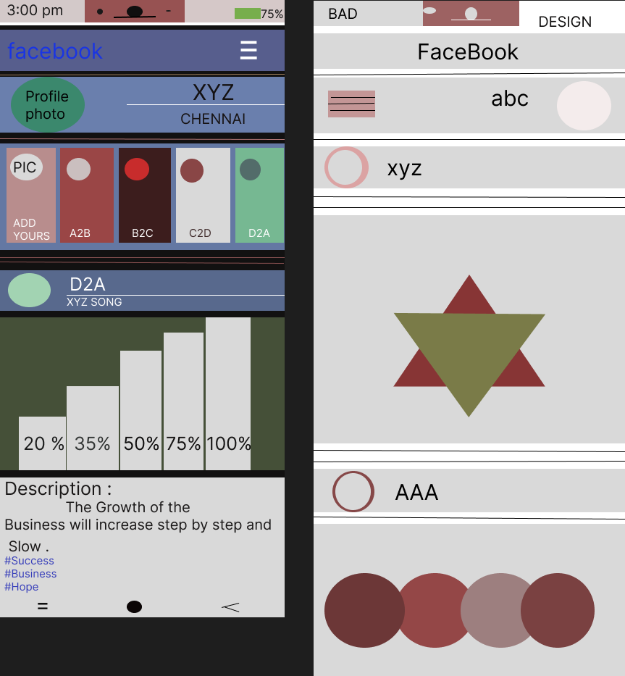

GOOD DESIGN | BAD DESIGN
MORE SPACE ARE USED AS USEFULL BY ADDING MORE DATA. | LOT OF SPACE ARE WASTED
THE STORY CAN BE VIEWED IN SEPARATELY HERE . | HERE WE CAN VIEW THE STORY BY TOUCHING ON THE PROFILE .
IN THIS , WE CAN VIEW THE SONG , LOCATION DETAILS OF THE POST . | WE CAN’T SEE THE SONG , LOCATION DETAILS IN THIS
IN THIS , WE CAN PROVIDE THE DETAILED DESCRIPTION ABOUT THE POST . | IN THIS , WE CANNOT PROVIDE THE DESCRIPTION IN THIS BAD DESIGN .

